
Tulip Centre
Cnr Van Wyk & Paragon Streets
Roodepoort
P.O. Box 1364
Houghton
2041
Tel: 011 760- 1117
PBO: 930026249
NPO: 069-051
Co. Reg. No. 2001/002800/08
Gauteng Dept. Edu. Reg. No. 700252031
info@tulipcombined.co.za
www.tulipcombinedschool.co.za

CODE
TULIP COMBINED SCHOOL NPC
Admission Contract

2026
Entered into between

Tulip Combined School NPC
And,

(Parent/Guardian’s Full Name(s) and Surname)

(Parent/Guardian’s ID. number)

(Parent /Guardian to initial each page at the bottom of this form)
Please note: This form must be completed in full. Failure to satisfy all requirements may result in admission being declined. All changes/corrections must be initialled or signed by parent/guardian. Completing the form does not guarantee that the learner has been accepted into the school.
**Please submit the following supporting documents to the school, for the application to be considered as complete:
Requirements | Tick Below | FOR OFFICE
- Proof of Payment (NON-REFUNDABLE)
- Copy of Birth Certificate
- Latest Progress Report from Previous School other than Tulip Combined School (Original)
- Transfer Letter from Previous School other than Tulip Combined School (Original)
- Copy of Clinic Card of learner
- Copy of Non-SA Citizen Permits (if applicable)
- Copy of a Valid Non-SA Passport (if applicable)
- Copy of ID – Mother
- Proof of Employment - Mother
- Proof of Address - Mother
- Copy of ID – Father
- Proof of Employment – Father
- Proof of Address - Father
- Copy of ID – Legal Guardians (if applicable)
- Proof of Employment – Legal Guardians (if applicable)
- Proof of Guardianship (if applicable)

Section A
Grade Applying For:

DETAILS OF THE LEARNER
(Please TICK where applicable)
Surname:
Initials:
First Name:
Other Names:
Date of Birth: | YYYY | MM | DD
Gender: | Male | Female
Race: | African/Black | Asian/Indian |  |  | Coloured |  | White | Other

Citizenship:
SA Citizen | Tick if applicable | ID number
Non-SA Citizen | Tick if applicable | Passport number
Study Permit | Tick if applicable | Permit number
Asylum Seeker | Tick if applicable | Permit number
Country of Residence:
If SA indicate province of residence:

Address and Contact Details:
Physical Address (where learner resides):
City/Suburb |  | Code:
Learner Cell:

Learner Email Address:

Emergency Details
Name & Surname:
Contact number:
Relationship:

General
Home Language: |  |  | Religion:
Deceased Parent (Tick) | Mother | Father |  |  | Both
Mode of transport: |  | Drivers Name:
Drivers Contact numbers |  |  |  | Vehicle Reg No.

For Grade 1 applicants only:
Indicate pre-primary education: | None | Non-Formal | Formal

Learner Medical Information
Medical Condition:
Allergies:
Medical Aid Main Member:
Medical Aid Name:
Medical Aid Number:
Dexterity of Learner: | Right-Handed | Left-Handed |  | Ambidextrous
Registered for Social Grant | Yes |  | No
Receiving Social Grant | Yes |  | No

Section B
SIBLINGS
Number of other Children at this school:

Please supply full names below:
Name: |  | Grade:
Name: |  | Grade:
Name: |  | Grade:

Section C
PARENT / GUARDIAN INFORMATION
Please complete a SEPARATE parent form for each parent living at a different physical address (request Annexure A) from the reception.
Account Payer Details:
Relationship to Learner:
Learner resides with this parent/s |  | Yes | No
Title:
Initials:
Surname:
First Name:
Gender: | Male |  | Female
Home Language:
Date of Birth: | YYYY |  |  | MM |  | DD
Race: | African/Black |  |  | Asian/Indian |  |  | Coloured |  |  |  | White | Other
ID/Passport Number:
Residential Street Address:
City/Suburb: |  |  |  |  |  |  |  | Code:
Postal Address:
City/Suburb: |  |  |  |  |  |  |  | Code:
Occupation:
Employer:
Details of Spouse
Title:
Initials:
Surname:
First Name:
Gender: | Male | Female
Home Language:
Date of Birth: | YYYY |  | MM | DD
Race: | African/Black |  | Asian/Indian |  | Coloured |  |  |  | White | Other
ID/Passport Number:
Residential Street Address:
City/Suburb: |  |  |  |  |  | Code:
Postal Address:
City/Suburb: |  |  |  |  |  | Code:
Occupation:
Employer:

Contact Details of Parents
Home Telephone Number:
Work Telephone Number:
Cell Number:
E-Mail Address:
Spouse Work Telephone Number:
Spouse Cell Number:
Spouse E-Mail Address:


PBO: 930026249
NPO: 069-051
Co. Reg. No. 2001/002800/08
Gauteng Dept. Edu. Reg. No. 700252031
info@tulipcombined.co.za
www.tulipcombined.co.za

Tulip Centre
Corner Van Wyk and Paragon Street
Roodepoort
P.O. Box 1364
Houghton 2041
Tel: 011 760- 1117/8
Fax: 011 760-1513

(Non-Profit Company)

Section D
To be completed by the previous school and authorized by the principal.
Previous School Information
Name of School

Name of Principal

Name of Finance Officer
School contact number
School email address

Learner Information:
Full name of learner: __________________________________________________________________
Date of Birth: _____________________________________ Grade: __________________________
Number of years in the school: _______________________
Date last attended: _________________________________
Reasons for leaving: _______________________________________________________________________________________________________________________________________________________________________________________________________________________________________________________________

Academic Performance:
Any awards or achievements: ___________________________________________________________
Any comments: _______________________________________________________________________________________________________________________________________________________________________________________________________________________________________________________________

Behavioural Issues:
Any behavioural or disciplinary issues: _______________________________________
Any suspensions or expulsions: ___________________________________________
Any comments: _______________________________________________________________________________________________________________________________________________________________________________________________________________________________________________________________

Previous School Financial Clearance:
1st Account payer ID No: ______________________________________________________________
Name & Surname: ____________________________________________________________________
2nd Account payer: ID No: ____________________________________________
Name & Surname: ____________________________________________________________________ Annual fee for 2023 R___________________
Were account up to date at time of leaving ___________________
Any fees outstanding R___________________
Any comments: _______________________________________________________________________________________________________________________________________________________________________________________________________________________________________________________________

This is to certify that the above person/s has paid the school fees as indicated.

___________________________________ ___________________
Signature of Finance officer Date

___________________________________ ___________________
Signature of Principal Date

___________________________________ ___________________
Signature of Parent(s)/ Guardian(s) Date
SCHOOL STAMP
We thank you for your attention to this matter.

Yours in education,
Ms. M. Nadar
Admissions Manager
(On behalf of the SSMT and Directors)

Only applicable to learners applying in Senior Phase and FET
SECTION E
LEARNER NAME: _____________________________________________________ PARENT NAME: ______________________________________

SIGNATURE: __________________________________________________________ SIGNATURE: _________________________________________

GRADE IN 2024: ______________ DATE: _______________________ DATE: ________________________________________________

TULIP COMBINED SCHOOL NPC
SUBJECT CHOICES
SENIOR PHASE: GRADES 7 - 9
Choose ONE First Addition Language by making a clear (X) in the coloured block.

 | AFRIKAANS |  | ISIZULU |  | SETSWANA

FURTHER EDUCATION AND TRAINING (FET): GRADES 10 - 11
Choose only ONE subject stream by making a clear (X) in the coloured block, thereafter, make the necessary selections using the remaining blocks where applicable for the desired stream.

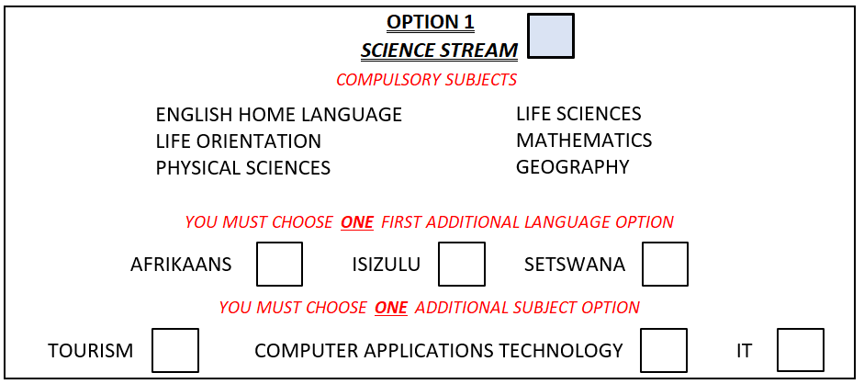
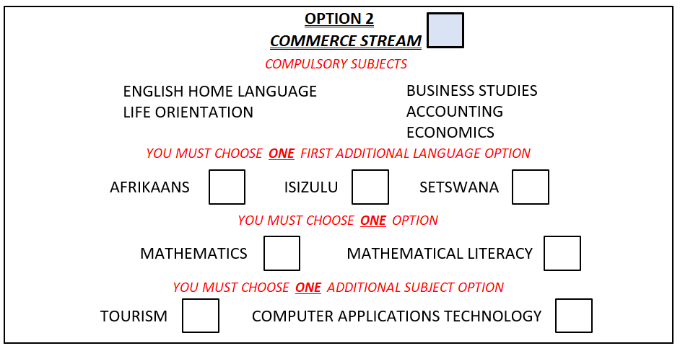
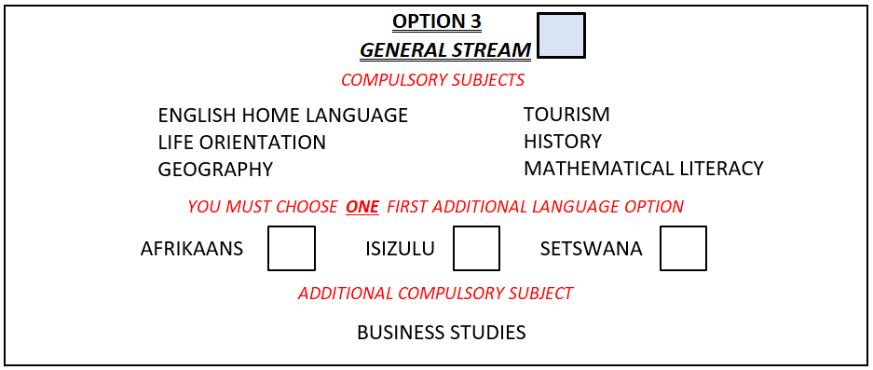
PASS REQUIREMENTS
FOR 2026 GRADE 10 LEARNERS

- The Science stream may only be selected by learners who have passed Mathematics and Natural Sciences with 50% and above in grade 9.
- CAT and IT can only be chosen if a learner obtains 50% for Mathematics.
- The Commerce stream many only selected by learners who have passed EMS with 50% and above in grade 9.
- The choice of the First Additional language for FET, must be in line with the language the learner did in grade 9.
2026 REQUIREMENTS
FOR FET LEARNERS

- CAT and IT can only be chosen if a learner obtains 50% for Mathematics.
- Grade 11 learners may only choose CAT or IT if they have done the subject in Grade 10.
- A learner may not do both CAT and IT.

PARENT/GUARDIAN DECLARATION AND CONTRACT OF ENROLMENT
The person/s whose details appear in Section ‘C’, declare that he/she/they are the parent/s or legal guardian/s of the Child/Children, whose details appear in Section “A” and any supplementary issue thereof. Each parent, alive and of full capacity, must complete these details and sign this contract. If one parent is the custodian parent, then the non-custodian parent, if not a signatory, must affirm in writing his or her consent hereto as a pre-condition. The rights and obligations contained in this Contract are binding on every person who signs this Contract and must be carried out in order for the Child to be successfully enrolled at the School.
IMPORTANT NOTICE
By signing or initialling or otherwise entering into this Contract you agree to the terms and conditions contained in this document as well as any terms and conditions contained in the Policies of the School, which form part of this Contract. If there is any provision in this Contract that you do not understand, please ask for an explanation before signing. This Contract contains clauses which may appear in similar italics text style to this notice and which:
- may limit the risk or liability of the School or a third party; and/or
- may create risk or liability for you; and/or
- may require you to indemnify the School or third party; and/or
- serve as an acknowledgement, by you, of a fact.
Your attention is drawn to these clauses because they are important and should be carefully noted. The rights you have in this contract are in addition to and do not affect the statutory rights and remedies you have under consumer protection law. In the event of conflict between this contract and consumer protection law, your statutory consumer protection rights will prevail. Nothing in this document is intended to or must be understood to unlawfully restrict, limit or avoid any rights or obligations created for you or the School in terms of the Consumer Protection Act.
- DEFINITIONS In this contract:
  - ‘Additional fees’ means those prices for the Additional Goods/Services and additional costs and levies required from time to time and notified to you in advance, to provide adequately for the education and related activities and services provided to your Child, including the costs of extra-curricular activities or special educational needs;
  - ‘Additional Goods/Services’ means those goods or services that may from time to time be provided to or for the benefit of the Child, as determined by the School from time to time;
  - ‘Registration Fee’ means the fee paid by the Parent/s to cover all the administrative costs involved in registering a Child at the School.
  - ‘Child’ means the child or children (of any age) admitted by the School to be educated, whose details appear in Section ‘A’, as well as the Children whose details appear in any subsequent Sections herein.
  - ‘Consumer Protection Act’ means the Consumer Protection Act, No 68 of 2008.
  - ‘Contract’ means this document, including all its annexures as well as any Policies;
  - ‘Directors’ means the directors of the company that manages and operates the School.
  - ‘Fee’ means any amounts owing to the School for a Child’s enrolment, education, and related activities at the School. Such Fees shall be clearly communicated to you in advance and may include, but are not limited to, the:
- Application Fee
- School Fees
- Additional Fees
- Outstanding Fees
  - ‘Parent’ or ‘you’ means each person who has signed this Contract as a parent or legal guardian of a Child, whose details appear in Section ‘C’,
  - ‘Parties’ means the Parent/s and the School;
  - ‘Policies’ means the rules, codes, policies, protocols and principles adopted by the School, as published by the School from time to time, which are used to regulate the day-to-day running of the School.
  - ‘School Senior Management Team means the persons appointed by the board of director the School to be responsible for the day-to-day management of the School, including anyone to whom such duties have been delegated;
  - ‘School’ or ‘we’ means Tulip Combined School NPC.
  - ‘School Fees’ means the money payable by the Parent/s to the School in connection with a Child’s education, excluding Application Fee or Additional Fees;
  - ‘School Rules’ means the rules of the School, a copy which is provided in the form of the Parent Handbook
  - ‘The Team’ means collectively the Board of Directors and the School Senior Management Team.
  - ‘Term’ means a division of the academic year and is the time during which the School holds classes, as notified to the Parents from time to time.
  - ‘Third Party’ means the person or entity, other than the Parent or guardian, nominated by the Parent or guardian to be responsible for the payment of any one or more or all of the Fees, provided that nomination will not absolve the Parent or guardian from the liability for those said fees.

- GENERAL OBLIGATIONS OF THE SCHOOL
  - The admission and enrolment of learners to the School is at the discretion of the School Senior Management Team, acting in terms of the School’s Admission Policy, who may refuse a learner’s admission to the School without giving reasons therefore and may grant temporary or provisional enrolment to the School subject to such further terms and conditions which may be imposed. School Senior Management Team may, at their discretion, cancel enrolment in accordance with the Rules.
  - For the sake of clarity, this Agreement regulates the enrolment and admission of your Child to the School and also regulates the relationship between the School, your Child, yourself and/or a Third Party once your Child is admitted and enrolled with the School. Subject to clause 2.1, nothing in this Agreement should be interpreted as a representation or warranty made by the School that your Child will be admitted to and enrolled with the School.
  - While your Child remains a learner of the School, we undertake to exercise reasonable skill and care in respect of his/her education and welfare. This obligation will apply during school hours and at other authorized times when your Child is permitted to be on School premises or is participating in activities organised by the School.
  - We shall monitor your Child’s progress at the School and produce regular written reports. We will advise you if we have any concern about your Child’s progress, but we do not undertake to diagnose any learning disability or other condition: a formal assessment can be arranged either by you or by the School at your expense.
  - The parties take cognisance of the limitations of the School’s physical environment, facilities and resources which limit its ability to provide high quality education to children with special educational needs (whether due to neurological barriers, hearing impairments, visual barriers, physical barriers, behavioural or emotional barriers or any other medically assessed special need). To the extent that, in the reasonable opinion of the School Senior Management Team, taken with the best interests of the Child as a key criterion, the School cannot, or can no longer, provide adequately for your Child’s special educational needs, the School may not offer enrolment with the School or may cancel this contract in terms of clause 9.3.

- DISCLAIMERS
  - You acknowledge that the School does not take any responsibility for any theft or loss of, or damage or destruction to any property of whatever nature (including School clothing, sporting equipment, books, or any other personal possessions) brought on to the School premises by your Child, unless the School or its staff are in the physical possession of that property and damage occurs to that property either because:
    - the School or its staff treated the property as their own; or
    - the School or its staff did not exercise the degree of care, diligence and skill that can reasonably be expected of a person responsible for managing property belonging to another person, when handling, safeguarding or using the property.
  - Unless you expressly notify us in writing to the contrary, you consent to your Child participating, under supervision, both in and outside the School, in sports and other activities (including contact sports) which may entail some risk of physical injury, as well to your Child travelling to and participating in School activities and programmes outside the School. Subject to the School taking reasonable care to avoid harm and save for any gross negligence on the part of the school, its employees or agents, the School is not responsible for loss or damage resulting from such sports, activities or programmes and you indemnify the School against any claims in that regard.
  - The school reserves the right of admission and entry to the premises.
INITIALS
- PARENT’S GENERAL OBLIGATIONS
  - You will inform the School in writing, prior to the School entering into this Contract, of any special educational needs of your Child known to you, of the kind referred to in clause 2.5.
  - In order to fulfil our obligations, we need your co-operation. Without detracting from any specific obligations contained in this contract, you are required to: fulfil your own obligations under these terms and conditions; encourage your Child in his or her studies, and give appropriate support at home; keep the School informed of matters which affect your Child; maintain a courteous and constructive relationship with School staff; and attend meetings and otherwise keep in touch with the School where your Child’s interests require you to do so.
  - The Board of Directors and School Senior Management Team may at their discretion require you to –
    - remove your Child if your behaviour is, in the reasonable opinion of the members, so unreasonable as to affect or likely affect the progress of your Child or another child (or other children) at the School or the well-being of the School staff or to bring the School into disrepute; or
    - remove or may suspend or expel your Child from the School, if he/she considers that your Child’s attendance, progress or behaviour (including behaviour outside school) is seriously unsatisfactory and in the reasonable opinion of The Team the Child’s removal is in the School’s best interests or those of your Child, other children or the wider School community; and
    - in either case, you will be asked to remove your Child either immediately and without notice, or at a specified date that is shorter than full term, with or without notice in any form, as is reasonable under the circumstances, and the School will not be required to give you a full term’s written notice under these circumstances, but should The Team exercise this right, you will be liable to pay any outstanding fees upfront up to and including the time of termination, likewise any prepaid/advance payment fees applicable to a period after termination less, any amounts owing, will be refunded to you.
  - The School rules, set out in the Welcome Pack, has examples of offences likely to be punishable by suspension or expulsion. These examples are not a closed list and a child may be expelled or suspended for offences which are not included in these examples. In particular, the School Senior Management Team may decide that suspension or expulsion for a lesser offence is justified where there has been previous misbehaviour by the child or the circumstances of the case otherwise justify such action.

- POLICIES OF THE SCHOOL
  - You declare that you have read and understood the Policies of the School as adopted and may have been published from time to time and agree to abide by these. The School undertakes to make these available to you on request.
  - You undertake to comply with all the rules and regulations of the School and acknowledge that it is your responsibility to make yourself familiar with the policies.
  - You acknowledge that you are responsible for your Child, whether on the property of the School or not, after the notified finishing times of any school activity/event/function and that you will ensure that your Child obeys all school rules and policies where they apply to the Child.
- ACCEPTANCE AND REGISTRATION FEE
  - A Registration Fee shall be paid before submitting the Application Forms should admission take place after the “Admission period”.
  - A further payment of the first month’s school fees is payable when tendering this Contract and application form.
INITIALS
- PAYMENT OF FEES
  - You have absolute responsibility for the payment of any Fees applicable to your Child attending the School. You also acknowledge that School fees are payable in advance and that cash ATM deposits and Electronic Funds Transfers (EFTs) and Card payments are the only acceptable forms of payment in the case of monthly school fees. If you are unclear about any of your financial obligations, the school will provide an explanation on request.
  - School fees are billed over 12 months. The full year's fees are payable over 12 months and apply even if the child starts at any time within the first Term, however all prior fees leading to the commencement date must be paid upfront. If the child starts after the admission period is over, the fees are charged pro-rata in addition to a Late Registration Fee of R3000.00 being paid upfront.
  - You and/or the Third Party accept the Additional Goods/Services. The School will, as far as reasonably possible, give you notice prior to providing such Additional Goods/Services. You and/or the Third Party expressly agree to the delivery or performance of the Additional Good/Services and accept the liability for payment thereof, in accordance with clause 7.1. You and/or the Third Party acknowledge that the Additional Goods/Services are not unsolicited, within the meaning of the Consumer Protection Act or otherwise and that you have expressly accepted such Additional Goods/Services.
  - You and/or the Third Party accept that you/it will be liable for the payment of the Additional Goods/Services. Such Additional Good/Services include payment for stationery, outings or any other Additional Goods/Services required by the School to provide your Child adequately with the educational services in terms of this Agreement. These will be invoiced in advance with the School fees in relation to on-going services required by you (e.g. enrichment courses, meal plan, etc.) or in advance of their provision in relation to ad hoc services (e.g., visits to places of interest, etc.).
  - You confirm that the statement showing the amount owing by you or the Third Party to the School shall be rebuttable proof that the said amount is due, owing and payable. Where the quantum of the School’s claim is thereafter disputed by you or the Third Party, you or the Third Party shall bear the onus of providing that such amount is not owing and /or due and/or payable.
  - In the event of the Third-Party taking responsibility for the payment if the Fees, you by your signature hereto, hereby bind yourself jointly and severally in your personal capacity as surety and co-principal debtor with the Third Party for payment to the School of any amounts which are owing and may at any time become owing to the School by the Third Party.
  - You also acknowledge that if any instalment on account of a fee which is payable, is not paid on the due date; the whole balance of the fee outstanding will immediately become due and payable by you. No indulgence or grant of time by the School will constitute a waiver of its rights under this contract or otherwise.
  - You are entitled to elect (at enrolment and prior to the beginning of each school) whether to pay school fees annually or monthly. This is set out on our website as well as communicated to you on enrolment and in advance of any increase in school fees.
  - You agree that fees paid in advance will be deposited to the School and held in accordance with the Consumer Protection Act, but that the School will be entitled to treat the interest generated from such funds as income.
  - The School fees will be reviewed and increased annually at the discretion of The Team, considering the needs of the school.
  - This clause is a separate, divisible agreement from the rest of this Contract and will remain in effect even if the Contract terminates, is nullified, or cancelled for any reason.
You agree that the school, at its option but without being so obliged, will be entitled to institute legal proceedings for the recovery of any monies owing by you as a liquidated debt or debts to the School in any magistrate’s court having jurisdiction, in terms of sections 45 and 28 of the Magistrates’ Courts Act.

- PROTECTION OF PERSONAL INFORMATION
  - By entering into this contract, and unless you at any time instruct the School expressly and in writing to the contrary, your consent is given for the School to:
    - collect, store and process credit information about you and any Third Party or divorced or separated Parent responsible for payment of any or all amounts comprised in the Fees;
    - collect, store and process names, contact details and information relating to yourself and your Child, and to such information being made available to other parents/guardians, staff or responsible persons engaged or authorised by the School for School-related purposes to the extent required for the purpose of managing relationships between the School, parents/guardians, and current learners as well as providing references and communicating with the body of former learners;
    - include photographs, with or without name, of your Child in School publications, or in press release to celebrate the School’s or your Child’s activities, achievements or successes;
    - supply information and a reference in respect of your Child to any educational institution which you propose your Child may attend. We will take care to ensure that all information that is supplied relating to your Child is accurate and any opinion given on his/her ability, aptitude and character is fair. However, the School cannot be liable for any loss you or your Child is alleged to have suffered resulting from opinions reasonably given, or correct statements of fact contained, in any reference or report given by us; and
    - inform any other school or educational institution to which you propose to send your Child of any outstanding fees.
INITIALS
- TERMINATION AND NOTICE REQUIREMENTS
  - For the avoidance of doubt, this contract will terminate at the end of the applied academic year. This contract therefore has a one-year term.
  - You have the right to cancel this contract at any time, for any reason, provided that you give the School a full Term’s notice, in writing, of this intention before the withdrawal of the Child from the School. Alternatively, a full Term’s fees (including Additional Fees pro-rated for the term as well as any outstanding balances) is payable to the School in lieu of notice, and as a reasonable cancellation fee taking into account the nature of the educational services, capacity planning and reasonable potential to fill the vacancy. Such amount is due and payable on the first day of the Term which would have been the final Term if the appropriate notice had been given. Should you have elected to pay annual school fees or should any additional fees have been paid in advance, those fees will be credited in proportion to the terms remaining, less any amount payable in lieu of appropriate notice.
  - In addition to the rights of The Team in terms of clause 4.3, the School also has the right to cancel this contract at any time, for any reason, provided that it gives you a full Term’s notice in writing, of its decision to terminate this contract. At the end of the Term in question, you will be required to withdraw the Child from the School, and any prepaid fees applicable to a period after termination, less any amounts owing, will be repaid to you.
  - This is without prejudice to the School’s other remedies: the School may cancel this contract immediately and has no obligation to return any pre-paid fees to you if you are in material breach of any of your obligations and have not (in case of a breach which is capable of remedy) remedied the material breach with twenty (20) business days of a notice from the School requiring you to remedy the breach, and in addition it may claim payment of all monies then owing and damages equal to one Term’s fees (as calculated at the time of cancellation) taking into account the nature of the services, capacity planning and reasonable potential to fill the vacancy.
  - In cases where a material breach occurs upon failure to pay school fees, the school is entitled to terminate this contract and exclude the learner for the school.
  - For the purposes of this contract, a material breach is considered to exist where you or your Child (as the case may be):
    - fail to uphold the Policies and/or Rules of the School;
    - fail to pay Fees when due;
    - fail to fulfil all legal requirements necessary for your Child to attend school in South Africa, if any of these legal requirements apply to your Child, for example, failure to obtain a valid study permit for your Child if he/she is a foreign citizen; or
    - act in such a way that you or the Child become seriously and unreasonably uncooperative with the School and in the opinion of the Principal, you or your Child’s behaviour and/or any misconduct that negatively affects your Child’s or other children’s progress at the School, the well-being of School Staff, or brings the School into disrepute.

- GENERAL
  - You choose the residential address set out in Section ‘C’ as your chosen legal address for the service of all notices and legal process and the postal and e mail addresses for all other communications by the School to you.
  - You commit to providing the necessary data and devices for your child/children to partake in online learning at your own expense.
  - You confirm that all the particulars that you may furnish or that you have furnished to the School on this contract or otherwise from time to time are or will be, to the best of your knowledge and belief, full, true and accurate.
  - You undertake to advise the School in writing of any changes to the details included in this contract.
  - Tulip Combined School NPC is an independent school and reserves all rights.

- JURISDICTION AND GOVERNING LAW
  - The contract between you and the School is governed by South African law.

- VARIATIONS
  - We reserve the right to change or add to these terms and conditions from time to time without notice for legal, safety or other substantive reasons or in order to assist the proper delivery or education at the School.

- PARTIAL INVALIDITY
  - Each term and condition contained in this agreement is separate from the other terms and conditions in the sense that if anyone is determined to be illegal and unenforceable, it will simply be disregarded and of no force and effect. But the agreement will otherwise remain valid.
  - It is a condition of attendance at the School that you sign in the space provided. The Team may at its discretion consider this declaration and Contract to be null and void if this document is altered in any way.

DECLARATION:
I/we, the undersigned, do hereby declare that I/we have read and understood and agree to the terms of this Contract.
I/we, the undersigned, do hereby declare the above information has been correctly updated. I/we, fully understand failure to provide correct information is considered a breach of contract and may affect the admission of my child, furthermore I understand that this information is vital for operational aspects and may have a direct negative impact on my child, especially (but not limited to) in case of emergency, where the school cannot be held liable as a result.

SIGNED by the Child’s,
Name of Mother / Guardian (Please Print): ________________________________ Signature: ___________________________
Name of Father / Guardian (Please Print): ________________________________ Signature: ___________________________
Date: ________________________________
Office use only:
Date:
Accepted:
Accession Number:
Rejected:
Reason for Rejection:

